**Basic Table Links for Database AspEPR3**

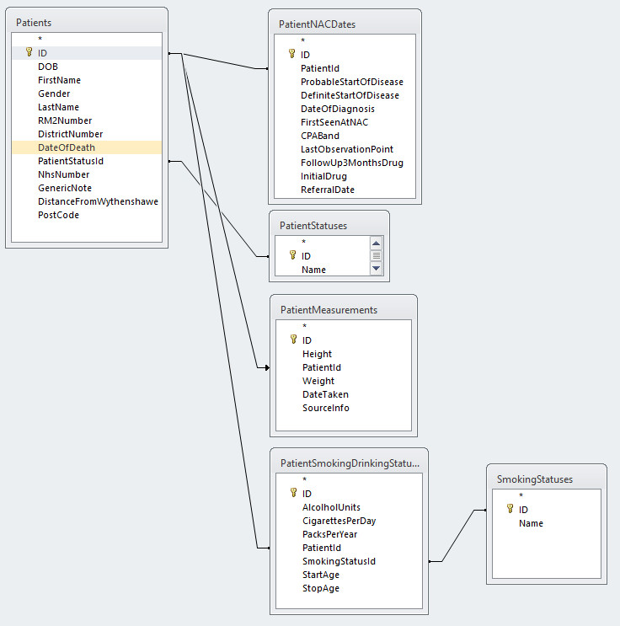

**Patient Diagnosis, Patient Surgeries, Patient Allergies Table Relationships**

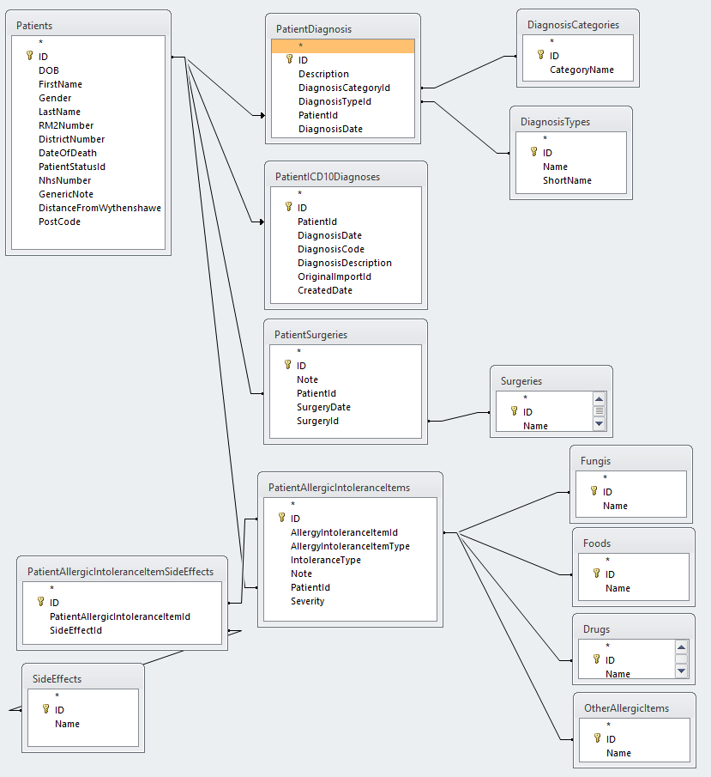

**Patient Drugs Table Relationships in AspEPR3**

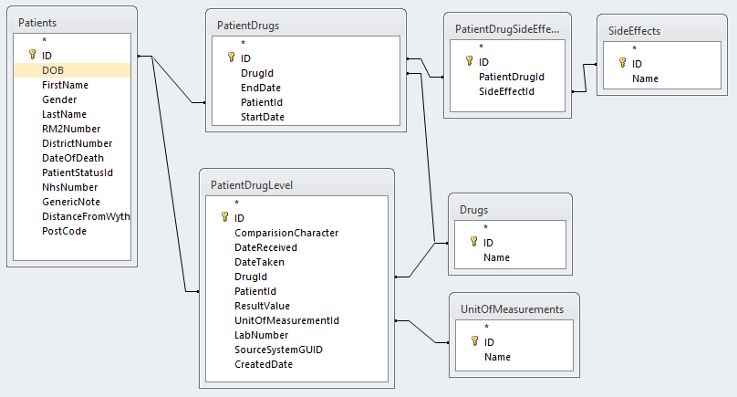

**Patients Clinical Measurements Table Relationships in AspEPR3**

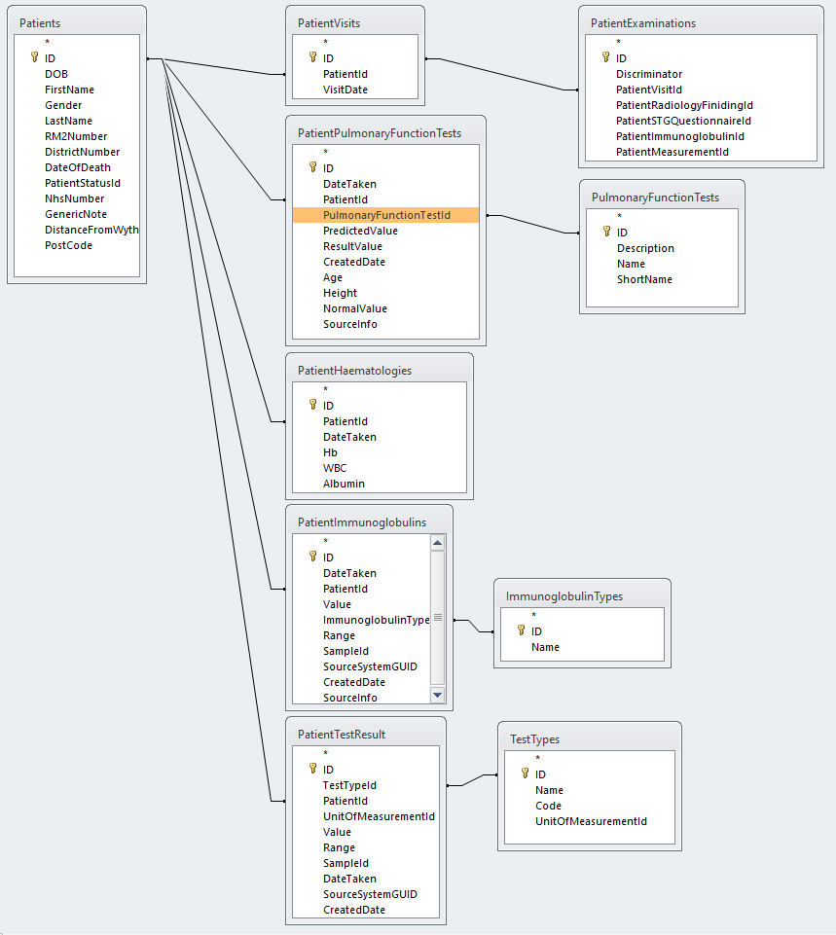

**Patient Radiology Related Table Relationships**

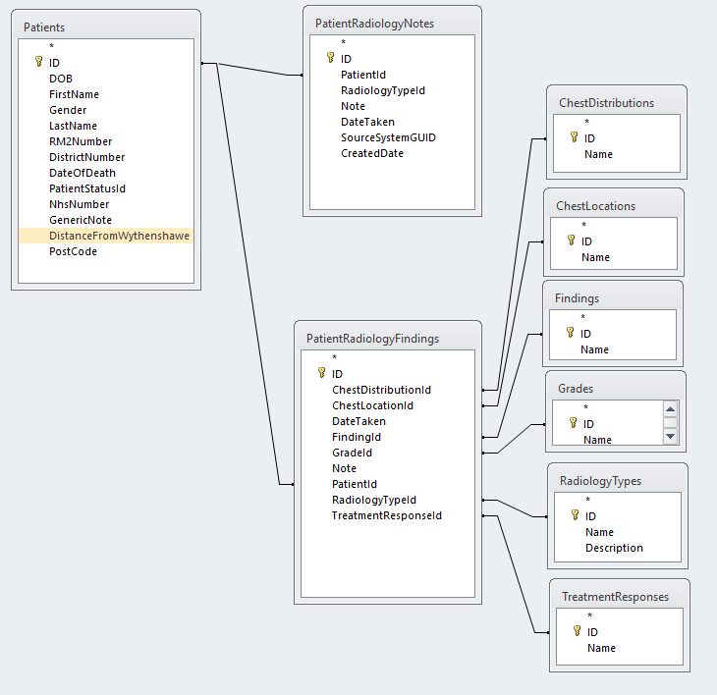

**Patient Clinical Score Table Relationships for AspEPR3**

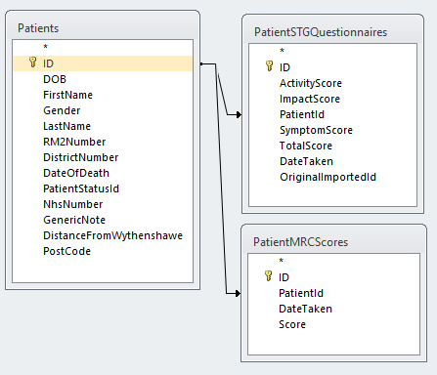

**Patient Medical Trials Table Relationships**

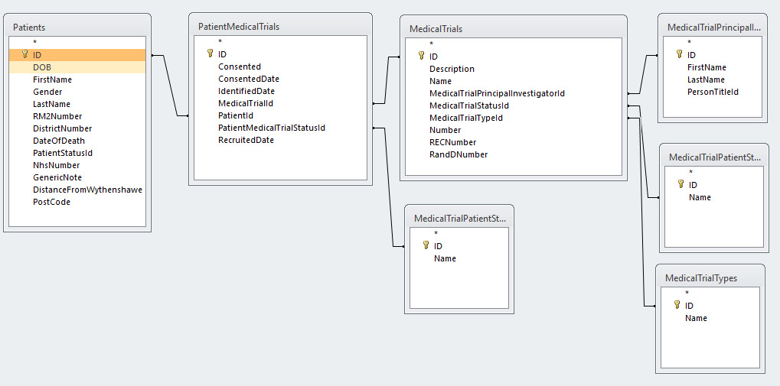

**Patient Visit Tables Relationships in AspEPR3**

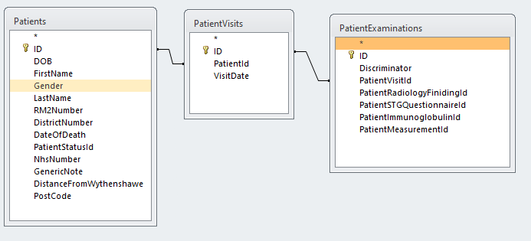

Patient Visits not implemented in Database.